Course Code: CPL801 | Course Name: Cloud Computing Laboratory
Class : | Batch :
Roll no : | Name :

Experiment : 07

Aim : Installation of Openstack

Theory:

What is Openstack?

OpenStack is a cloud operating system that controls large pools of compute, storage, and networking resources throughout a datacenter, all managed through a dashboard that gives administrators control while empowering their users to provision resources through a web interface.
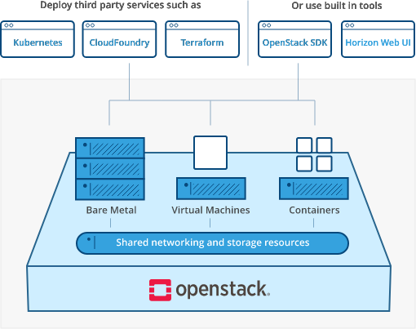

Explain the Openstack components and services?

OpenStack Services
An OpenStack deployment contains a number of components providing APIs to access infrastructure resources. This page lists the various services that can be deployed to provide such resources to cloud end users.
1.Compute
Nova - Compute Service
Zun - Containers Service
Qinling - Functions Service

2.Bare Metal
Ironic - Bare Metal Provisioning Service
Cyborg - Accelerators resource management

3.Storage
Swift - Object store
Cinder - Block Storage
Manila - Shared filesystems

4.Networking
Neutron - Networking
Octavia - Load balancer
Designate - DNS service

5.Shared Services
Keystone - Identity service
Glance - Image service
Barbican - Key management
Karbor - Application Data Protection as a Service
Searchlight - Indexing and Search

6.API Proxies
EC2API - EC2 API proxy

7.Web Frontend
Horizon - Dashboard

Explain the benefits of Openstack?

1. Great industry support
OpenStack has a thriving community of developers that collaborate with the users to design the platform best suited for any business needs.

2. Compatibility
For plenty of businesses, this provides the option of porting IaaS client applications from AWS to OpenStack-based IaaS providers with minimal effort.

3. Scalability
OpenStack itself is a highly scalable system. It can enable enterprises to spin up and spin down servers on-demand.

4. Security
In OpenStack, high level of security can be achieved through role-based access controls. Access and resource utilization can be controlled at the level of users, roles, and projects.

Attach the screenshots of the installation process.

Reference:
https://www.openstack.org/software/
https://www.mirantis.com/blog/how-to-install-openstack-on-your-local-machine-using-devstack/
https://docs.openstack.org/pike/index.html

Conclusion:

